Instructions for submitting your project idea
Robert Bosch Stiftung GmbH does not accept any unsolicited project applications. We only accept project ideas. In order to ensure that we can deal with your project idea in a timely and targeted manner, we request you to comply with the following instructions:

- Your project idea must summarize the contents and finance of the planned project.
- After your project idea has been examined by Robert Bosch Stiftung, you will either be requested to file an application or you will be sent a rejection.

Kindly send your project idea to one of the following email addresses where your inquiry best fits:

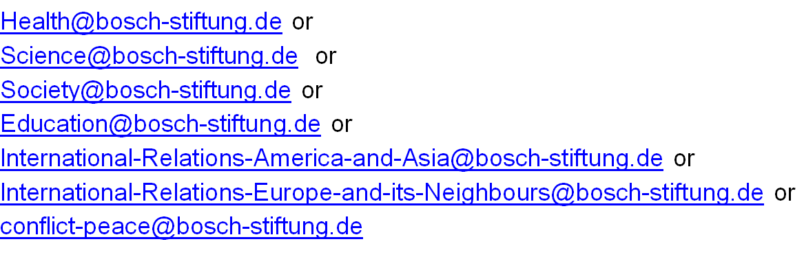
Please note that project ideas which do not provide a postal address cannot be processed.

Title of the project idea:

Please answer the following questions in brief:

1. Robert Bosch Stiftung is concerned with select areas of activity relating to the following subjects: health, science, society, education and international relations as illustrated at www.bosch-stiftung.de. Which of these areas of activity would you attribute your planned project to and why?

2. What is the issue/problem that you seek to address?

3. Describe your approach. To what extent is your approach innovative?

4. What goals do you seek to achieve (in what period of time) and how? How do you plan to monitor the desired change?

5. Which expertise do you possess in the field in which the project is to be conducted?

6. Describe the milestones for the planned course of the project.

7. What are the total costs the preliminary costing is based on? What percentage of this do you envisage to be met by funding from Robert Bosch Stiftung?

8. What potential or already established partners and supporters can you name?

9. Is the planned project a non-profit project?

